Setting up application environment

Install IBM Cloud CLI

(Customer Care Registry_PNT2022TMID52279)

**STEP-1**

Login with ibm.com ,Search with container registry in search catalog.

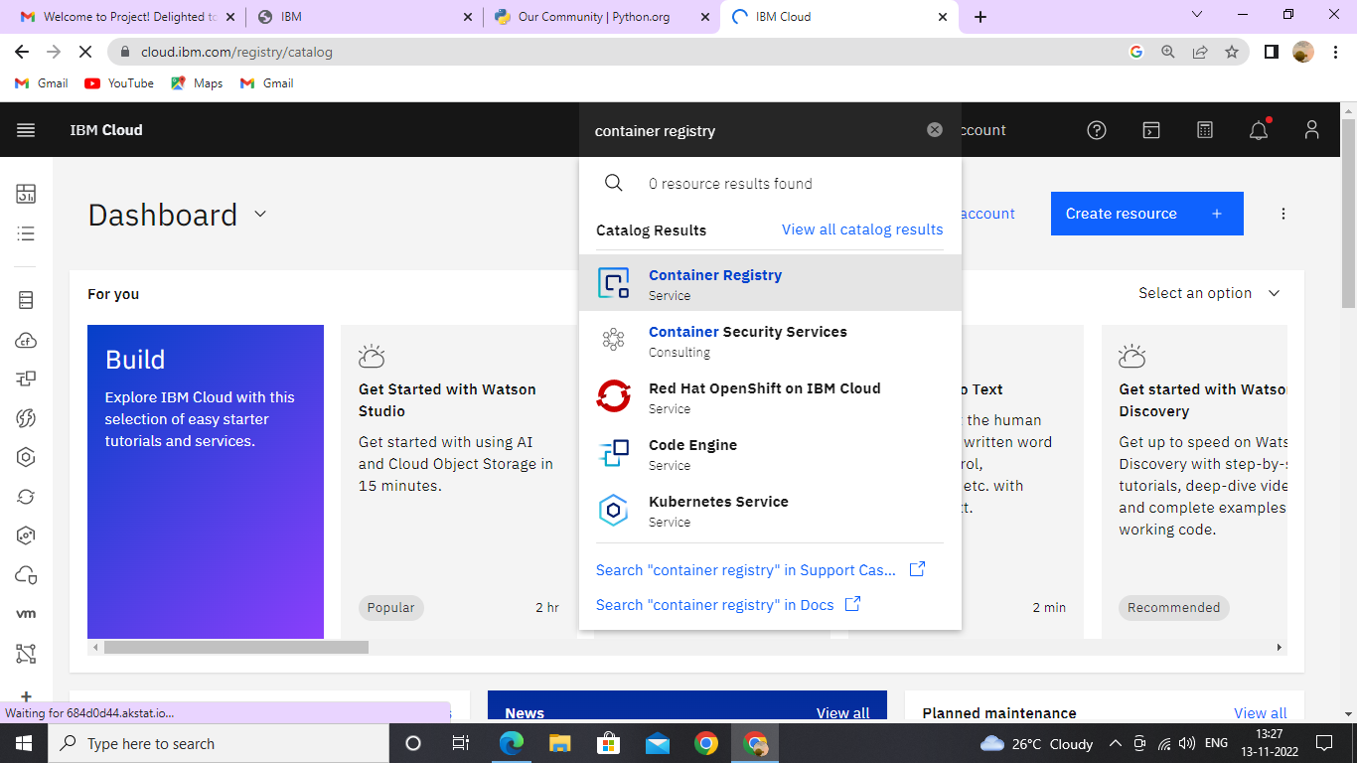

**STEP-2**

Click get started button.

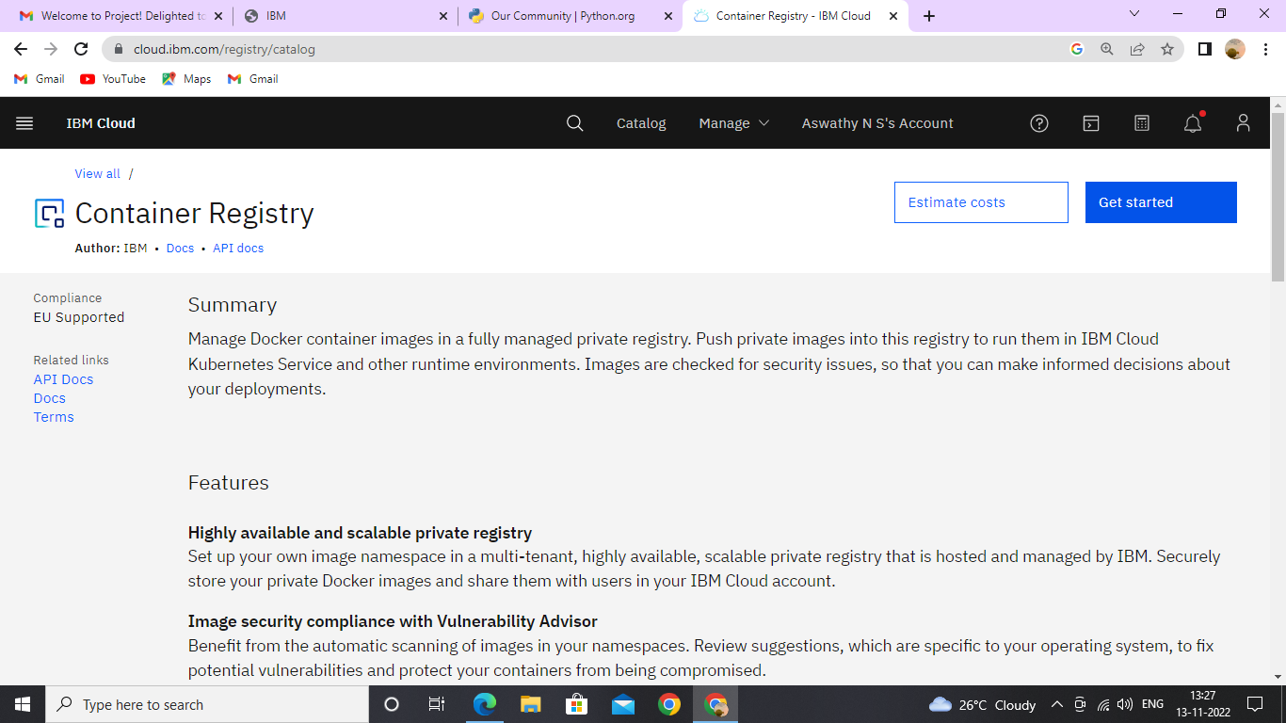

**Step-3**

List of commands, insert into our IBM cloud shell.

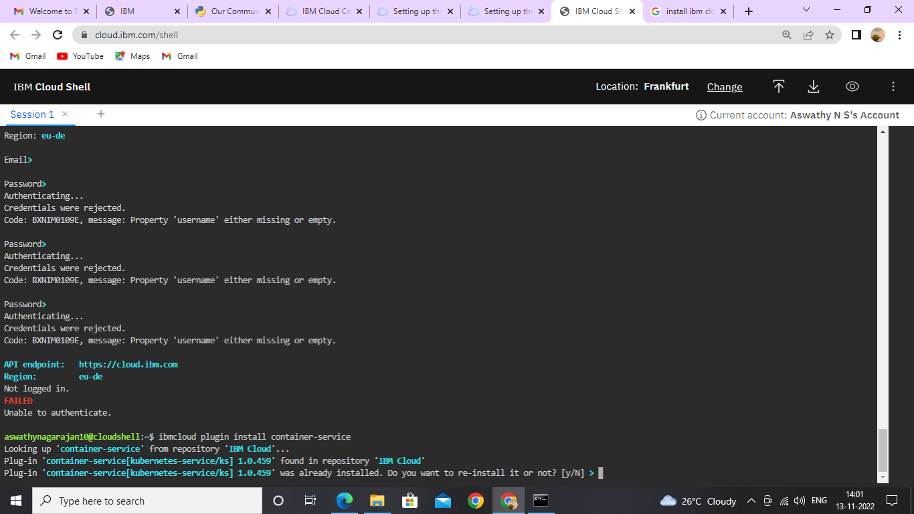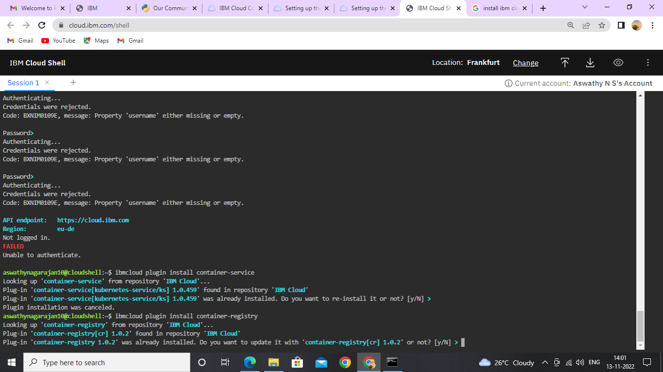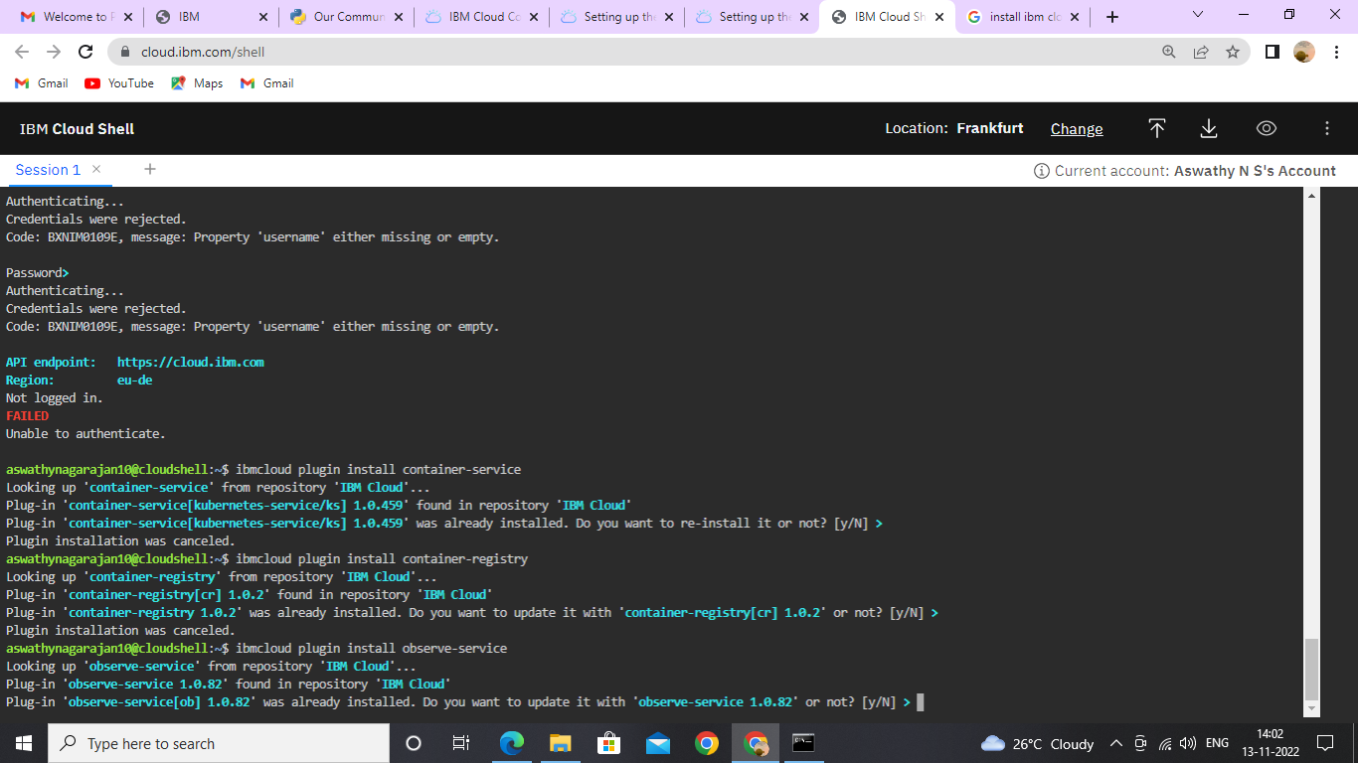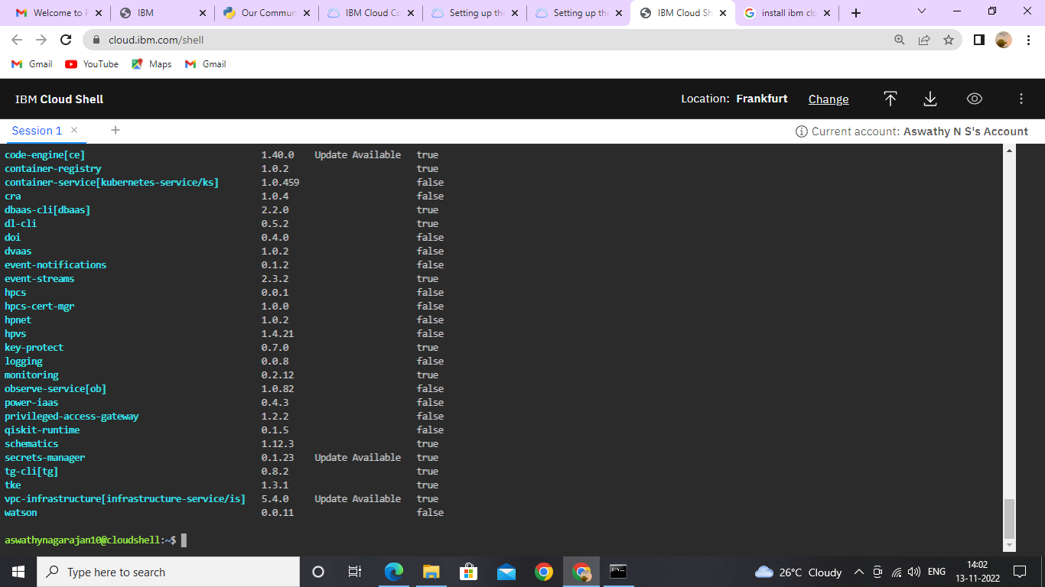

* After entering all commands, the cloud CLI installation is done.